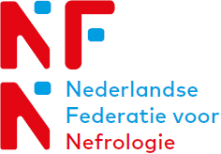
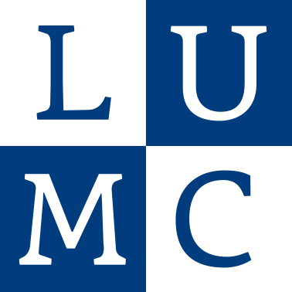
PLAN DAY - APRIL 6 2018
Platform AIOs and post-docs Nephrology

10:00 | Registration and Coffee
10:20 | Welcome
10:25 | Keynote:  Prof. Dr. C. van Kooten | Innate Immunity in Allograft Rejection and Renal Inflammation
11:00 | Laura van Dam | The Pathogenic Role of Excessive Neutrophil Extracellular Trap Formation is Different in ANCA-associated Vasculitis and Systemic Lupus Erythematosus
11:15 | Carla van Alem | Treating Acute Cellular Rejection with Liposomal Prednisolone – preclinical data from a mouse model
11:30 | Bram Voorzaat | Vascular Access Management after Kidney Transplantation
11:45 | Keynote:  Prof. Dr. F.W. Dekker | Pitfalls in Epidemiological Approach
12:30 | Lunch
13:45 | Keynote:  Prof. Dr. A.J. Rabelink | Custom Made Kidney Tissue
14:20 | Franca Witjas | De- and Recellularization of Kidney Scaffolds
14:35 | Anouk van der Velden | Restoring the Endothelial Glycocalyx
15:00 | Coffee and Cake
15:30 | Shosha Dekker | Clinical Aspects of Autosomal Dominant Polycystic Kidney Disease
15:45 | Jurriën Prins | A Novel Antisense Strategy to Combat BK Virus Replication
16.00 | Koen Groeneweg | Mesenchymal Stromal Cell Therapy in Transplant Recipients
16:15 | Keynote:  Prof. Dr. J.W. de Fijter | Perspective of the Transplanted Kidney
17:00 | Closing and drinks

PLAN DAY - APRIL 6 2018
Platform AIOs and post-docs Nephrology

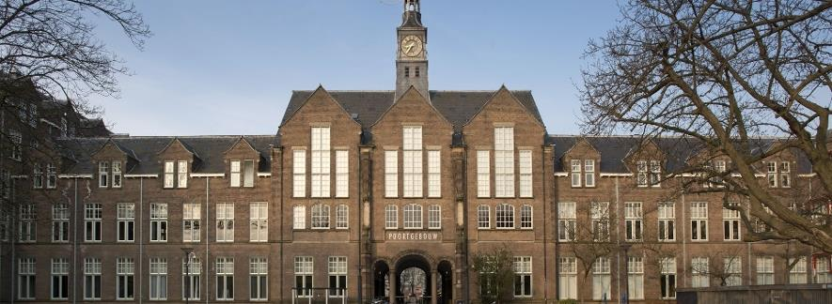
PLAN day is held at ‘Het Poortgebouw’ next to bus and railway station Leiden Centraal, LUMC side. The room is located at the first floor. The LUMC parking is located within walking distance.

Address:
Poortgebouw (see figure)
Rijnsburgerweg 10
2333 AA Leiden

